**PTP Accountant**

Reporting to Group Accounting Team Lead (PTP)

We are one big family in Rohlík. We see the world from the better side, and we are constantly looking for ways to make each other happier. We know that even seemingly small goodies can be of great importance, and therefore, together with the rediscovered power of humanity and helpfulness, we return to our roots. To nature, honest craftsmanship and the countryside, where there is inspiration for all who believe that it is time for good things and especially for good food.

**Department Overview**

Journal vouchers, month end, accounting, analysis, reporting, statements, invoices, payments, balances. Does it make your head spin? At the Finance Department we love it the most at Rohlik! We maintain the smooth running of the company and its financial health.

**Role Overview**

PTP Accountant role is part of Group Finance Centre, reporting to Group Accounting Manager (PTP). Role is overlooking all accounting activities for the relevant process – PTP, related to the Rohlik Group and other related entities.

**What we expect from you**

* Processing of Vendor invoices
* Processing of T&E
* Preparing accruals and other PTP related journal vouchers
* Open items resolution
* Assuring timeliness and quality of reconciliation process
* Participate on performance management and KPIs setting process
* Participate on Transitions, ERP implementation and other projects

**What we look for**

* 1-2 years of accounting experience in similar role
* Demonstrate experience in driving continuous improvement
* Czech and English language skills (written and verbal)
* Strong communication, interpersonal, and organization skills required

**KPI’s typical for the position**

* Timeliness invoice processing
* Timeliness of payment processing (%invoices paid within a due date)
* % Invoices overdue (#overdue invoices, #total backlog)
* Timeliness of expense claim processing

**What we offer**

* Your work will have a direct impact on the company's results
* We will implement your good ideas almost immediately – not waiting for the approval of the headquarters somewhere in the world
* You will not be bound by corporate processes
* Your work has to be innovative and meaningful, we do not want to follow trends, but set them
* Last but not least, we mainly offer a fair reward and the possibility of professional growth and education, also a great bunch of people around and a legendary company events

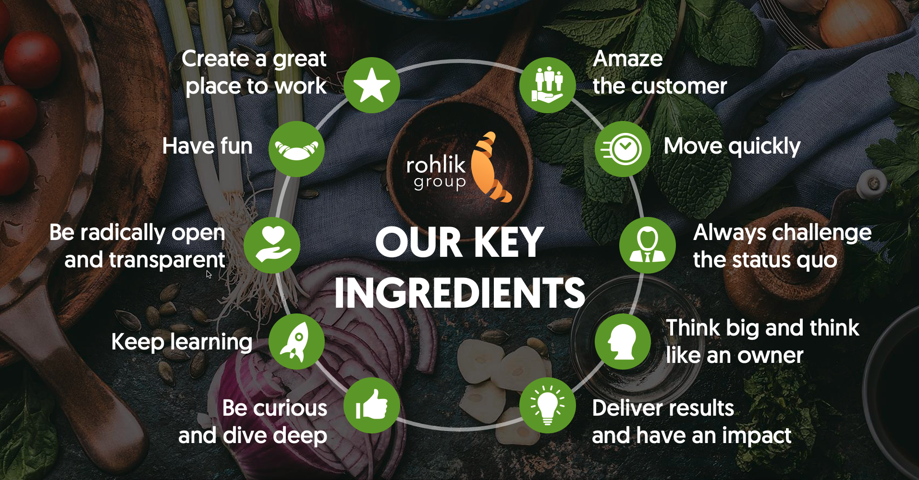

**Our Values**

* **Customer obsession:** Customer is in the center of our universe. Everything we do, we do for them.
* **Speed:** Better done than perfect. We build, improve and deliver fast.
* **Courage:** We are brave. We are not scared of taking ownership and making decisions.
* **Learning:** We keep learning. Information is power. Change is life and opportunity.
* **Winning:** The market standard is not good enough. We aim to win, be the best, and ahead of the market. We keep innovating.
* **Honesty:** We are open and honest to ourselves, to our teammates, and to our customers. We are able to accept feedback.
* **Optimism:** We fight in a tough environment. The more important it is to have fun and have a helicopter view.
* **Think big:** We are bold and daring in changing the future.